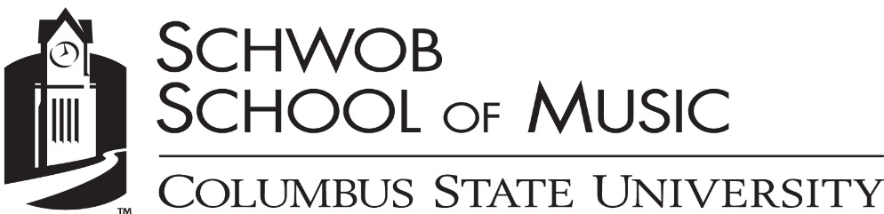
Saunders Center for Music Studies

Student Name, instrument

Accompanist Name, piano

Monday, April 15, 2019
RiverCenter, Legacy Hall/Studio Theatre
5:30 PM

Ich habe genug, BWV 82 J.S. Bach
(1685-1750)
Alexander Brosseau, baritone

Concerto in A-minor, RV 461 Antonio Vivaldi
I. Allegro non molto (1678-1741)
II. Larghetto
III. Allegro

A 6 Letter Letter for English horn alone Elliott Carter
(1908-2012)

Sonata for Oboe and Piano, Op. 185 Francis Poulenc
I. Elegie (1899-1963)
II. Scherzo
III. Deploration

Kleine Kammermusik, Op. 24, No. 2 Paul Hindemith
I. Lustig. Mäßig schnell Viertel (1895-1963)
II. Walzer. Durchweg sehr leise
III. Ruhig und einfach
IV. Schnelle Viertel
V. Sehr lebhaft

Student’s Name is a student of Applied Faculty Member.
This recital is given in partial fulfillment of the requirements for the Bachelor/ Masters/Artist Diploma of Degree Name.
Saunders Center for Music Studies

Student Name, instrument

Accompanist Name, piano

Monday, April 15, 2019
RiverCenter, Legacy Hall/Studio Theatre
5:30 PM

Ich habe genug, BWV 82 J.S. Bach
(1685-1750)
Alexander Brosseau, baritone

Concerto in A-minor, RV 461 Antonio Vivaldi
I. Allegro non molto (1678-1741)
II. Larghetto
III. Allegro

A 6 Letter Letter for English horn alone Elliott Carter
(1908-2012)

Sonata for Oboe and Piano, Op. 185 Francis Poulenc
I. Elegie (1899-1963)
II. Scherzo
III. Deploration

Kleine Kammermusik, Op. 24, No. 2 Paul Hindemith
I. Lustig. Mäßig schnell Viertel (1895-1963)
II. Walzer. Durchweg sehr leise
III. Ruhig und einfach
IV. Schnelle Viertel
V. Sehr lebhaft

Student’s Name is a student of Applied Faculty Member.
This recital is given in partial fulfillment of the requirements for the Bachelor/ Masters/Artist Diploma of Degree Name.

